Roger Johnson ’52 – Chapter Eternal
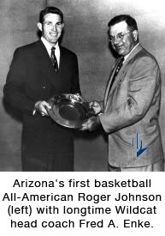Roger Johnson, Beta Phi ’52, the University of Arizona’s first All-American basketball player who also exceled at baseball, entered the Chapter Eternal on Jan. 27, 2010.
Brother Johnson was a third-team pick by the Helms Foundation. He finished his career with 1,046 points scored to average 12.3 points a game for his 76-game career He was the second Wildcat to top the 1,000-point plateau.
He was named to the all-Border Conference team three times (1950, ’51 and ’52) and received all-District 6 honors in 1950-51 and in 1951-52. In his senior year, he was voted the team’s most valuable player. In 1951 he received the Bobcats award for most outstanding senior athlete
Brother Johnson was a 1948 graduate of Tucson High School where he played basketball and was captain of the All-State team. He also played baseball and was team captain in his senior year.
In UA baseball, he was named All-America in 1951. After graduation he played for the Boston Red Sox organization. He joined the U.S. Air Force and rose to the rank of colonel. He was a career Air Force officer. He played on the All Air Force basketball team in 1957 and was player-coach of the Air Force team at Chaumont, France, in 1958.
A memorial service was held Saturday, Feb. 6 at 4 p.m. at Messinger’s Mortuary in Fountain Hills, Ariz.
Read an article on Roger Johnson from the Arizona Daily Star here.
