David M. Jones ’36 – Chapter Eternal
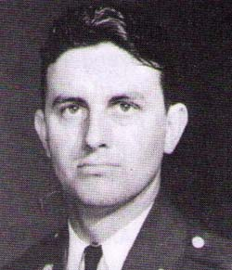David Jones, a Beta Phi (’36) who was named to the chapter’s Hall of Honor in 2005, entered the Chapter Eternal on Nov. 25, 2008. He was 94.
Jones was born on Dec. 18, 1913, in Marshfield, Ore., but he attended high school and college in Arizona, where he also enlisted in the National Guard. Jones was commissioned as a second lieutenant in the U.S. Calvary arm of the Arizona Army National Guard, but soon after he transferred to the Army Air Corps,where he began pilot training.
In 1942, Jones volunteered to fly for the Doolittle Project – a secret bombing raid on Japan in response to the attack on Pearl Harbor. The April 18, 1942, Doolittle Raids on five Japanese cities earned Jones the Distinguished Flying Cross.
Jones was then assigned as commander of the 319th Bombardment Groups in North Africa campaign of World War II. He was shot down over Tunisia and spent two-and-a-half years as a prisoner of war.
From early 1952 until mid-1955, Jones was commander of the 47th Bombardment Wing. He then began working in research and development as directory of the B-58 Test Force. At one time, he had more supersonic flying time in the B-58 then any other Air Force pilot.
Jones was later the deputy assistant administrator for manned space flight with NASA. In 1973, he retired with the rank of major general.
In the community, Jones was a past president of the Chamber of Commerce of South Brevard, Fla., he was a former trustee with the Florida Institute of Technology and the Florida Air Academy, and he was an active board member of the Doolittle Raiders Association.

